5.24: a) If there is no applied horizontal force, no friction force is needed to keep the box in equilibrium. b) The maximum static friction force is, from Eq. (5.6), so the box will not move and the friction force balances the applied force of 6.0 N. c) The maximum friction force found in part (b), 16.0 N. d) From Eq. (5.5), 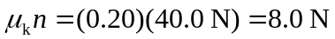 e) The applied force is enough to either start the box moving or to keep it moving. The answer to part (d), from
Eq. (5.5), is independent of speed (as long as the box is moving), so the friction force is
8.0 N. The acceleration is 